Radon Information for Real Estate Agents
- Simple Clear information for clients
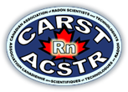

What is radon:
Being exposed to high levels of radon gas today makes us at risk of developing lung cancer in years to come.
Radon is a gas. It starts in the ground as uranium (a solid mineral), then becomes radium (still a solid), and finally radon (a gas). As a gas, radon moves through the ground and up to the surface.
When radon is in the outside air, it dilutes to low levels that are not a health concern.
When radon enters our homes, it can be present in high levels, which is why we need to test indoor spaces and reduce high levels.
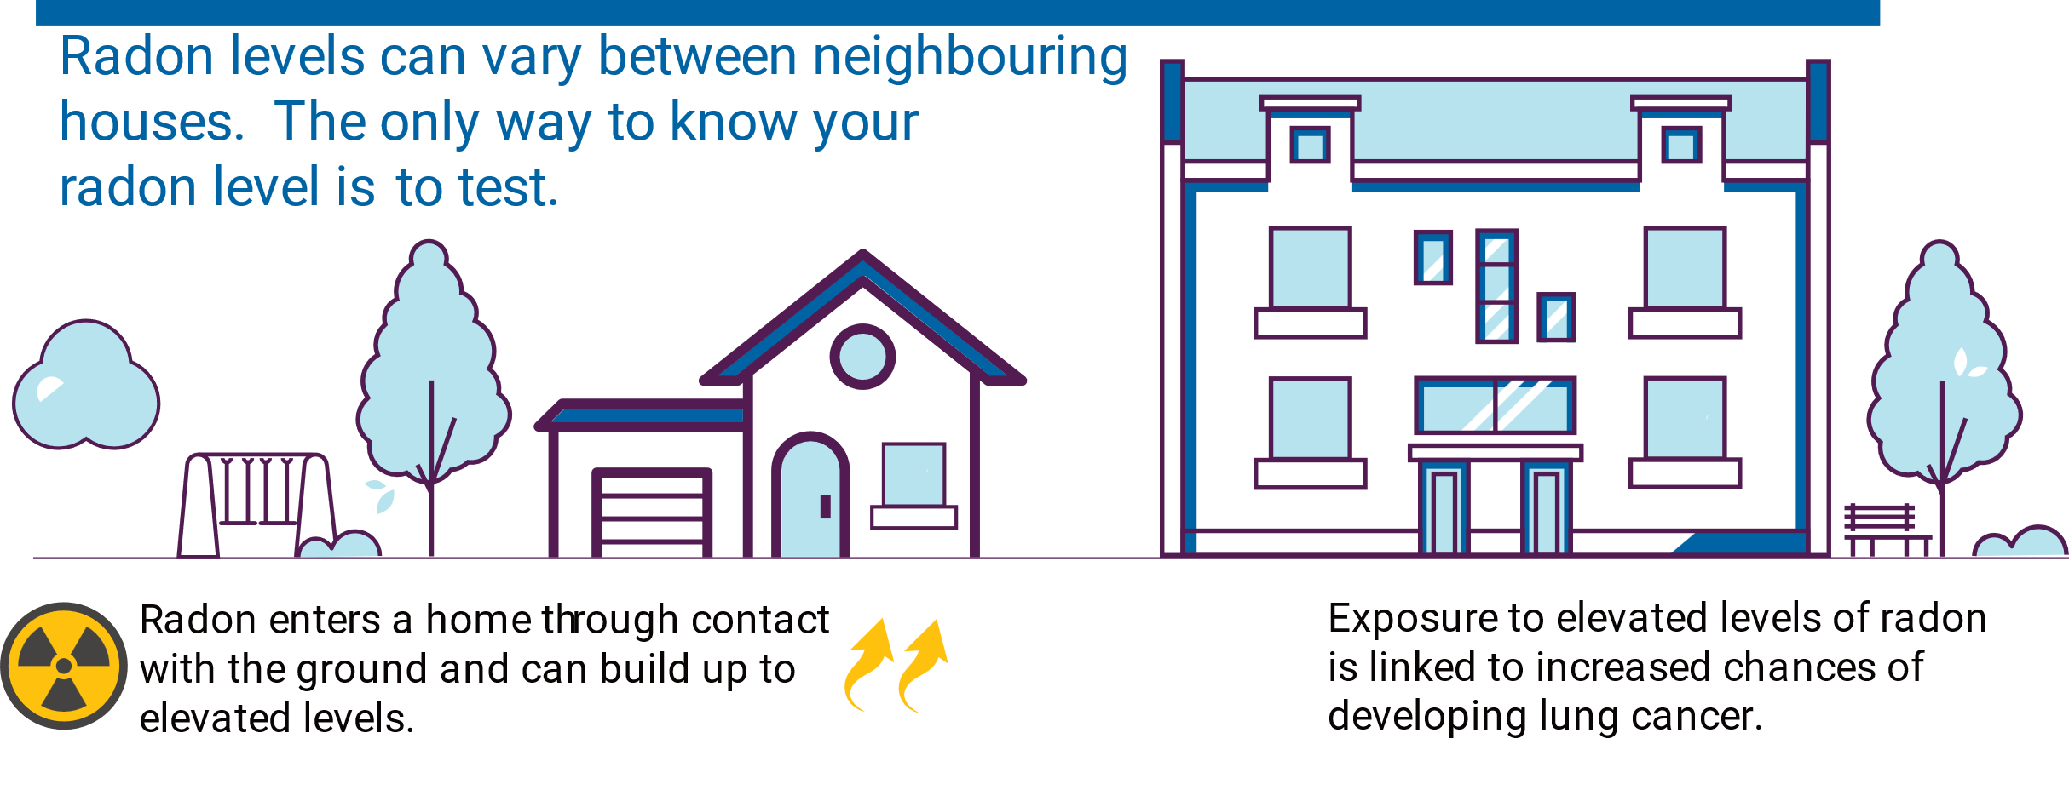
What do we do about it?
Measure and fix
It’s that easy. Make sure you use the right devices and techniques to measure.
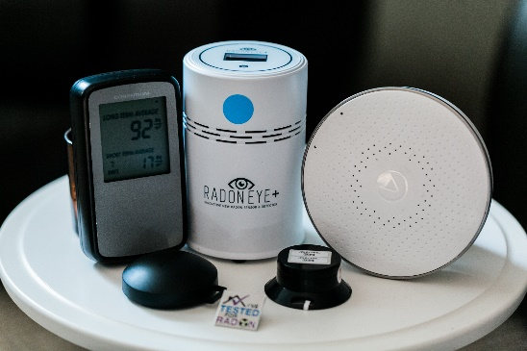
Test your home in an occupied room (bedroom or office) using a C-NRPP certified device. Ask questions first to ensure you know the device will be accurate and you know how and where to place the device. If you’re not getting the information you need, or if you’re uncertain, consult with a C-NRPP certified company or contact C-NRPP directly. (info@c-nrpp.ca)
Test Durations
Radon is not something that should be tested for quickly.
Radon levels can vary day to day and hour by hour. We recommend basing a decision for mitigation on a radon test that will most accurately predict an occupant’s annual exposure level. Health Canada and C-NRPP recommend basing a decision to mitigate on a long-term radon measurement during the heating season while the home is occupied. Long-Term Radon Measurement is a radon test which is of duration of 91 days or more upto 1 year.

Short-Term Radon Measurement –is a radon test which is of duration of at least 48 hours but up to 90 days
A short-term radon measurement can be conducted using greatly different test lengths. The minimum duration of a short-term radon measurement is 48 hours and it can last as long as 90 days, the longer the duration of the test, the more representative of the average annual radon concentration.
Short term measurements should always be part of a two-step process of short-term and long-term follow up measurement. C-NRPP and Health Canada strongly recommend that any and all short-term radon measurements be followed up with a long-term radon measurement.
You can hire a professional to test for radon, but make sure they are C-NRPP certified. They will use a certified device and place it properly.

How do we know RADON is a health issue?
Research in miners (especially uranium miners) first alerted researchers to radon as a health concern, but subsequent research in homes confirmed that radon wasn’t just an occupational hazard for miners. The elevated radon levels that can be found in homes also have a serious impact on our health.
Radon releases radioactive energy which can alter the DNA in lung cells, leading to lung cancer.
The relationship between radon and lung cancer is linear, which means that as the radon exposure increases (exposure = radon level x time) the risk also increases.
The combination of high radon levels and smoking greatly increases the overall risk of developing lung cancer.

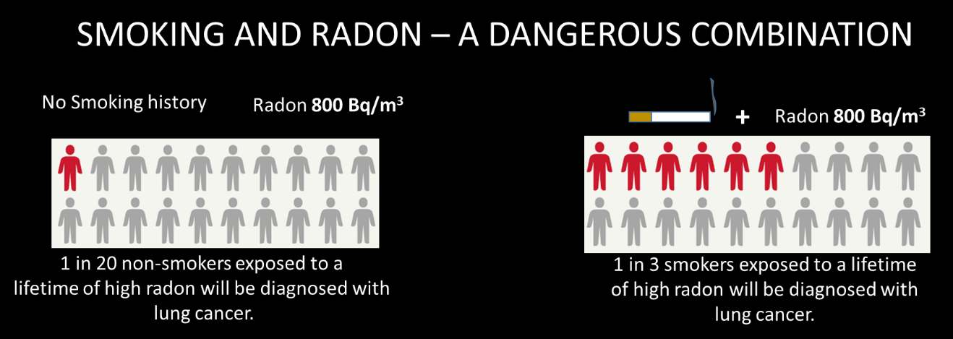

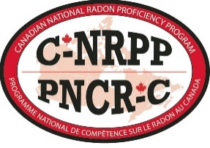
Every home can be fixed
C-NRPP is Canada’s national certification program for Radon Professionals:
Health Canada and CARST (the Canadian Association of Radon Scientists & Technologists) developed the certification program so that building owners had someone to help with testing and reducing radon levels.
To find a certified professional, head to: www.c-nrpp.ca/find-a-professional
Radon Measurement Professionals will help with testing a building for radon.
Radon Mitigation Professionals will help with fixing a building’s high radon.

A certified radon professional provides you with an impartial third-party to give you reliable advice.

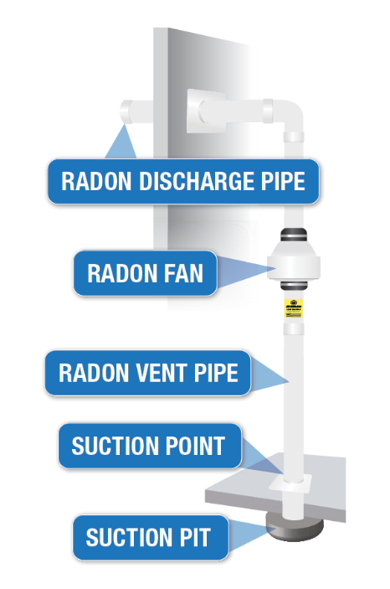
RESEARCH:
Health Canada has conducted research to confirm that a radon mitigation system is the most effective method of reducing radon levels.
HIRING a certified professional LOWERS RADON BY UP TO 90%
INCREASING home ventilation LOWERS RADON BY 25-50%
SEALING cracks LOWERS RADON BY AN AVERAGE 13%
Find online at: https://www.canada.ca/en/health-canada/services/publications/health-risks-safety/residential-radon-mitigation-actions-follow-up-study.html

Radon Mitigation System
A radon mitigation system is the most effective method to reduce radon levels in a home. It can be called by many names, but we want to focus on what it does.
A radon mitigation system provides a pathway for the gas to reach the outdoor air without entering the home.
Using a fan, a radon mitigation system creates an active pathway for radon, as well as moisture and other soil gases, to move directly from beneath the slab of the house to the outside air without entering the building.
Additional Benefits: Homeowners often find that once a radon mitigation system has been installed, their use of dehumidifiers reduces, smells are gone and the air quality is better. This is because a radon mitigation system is effective in removing other substances and moisture that had been entering the home from the soil in addition to radon.

Radon Control in New Homes:
In most provinces across Canada, the building code states that new homes must have a radon rough-in system. What do homeowners need to know? First off, the radon rough-in does not reduce radon; it’s simply the beginning of a system. The rough-in is included in new construction to make it easier and more cost effective to install a radon mitigation system should one
be required. Secondly, the rough-in must be properly capped, sealed and labeled, otherwise it could be introducing radon into the house.
Radon Rough-in:
Purpose is make it easier and more cost effective to install a radon mitigation system should one be required.

Homeowners need to test their home for radon and then decide if the radon rough-in needs to be finished into a Radon Mitigation System.

NOTE FOR BC: The building code in BC is divided into two approaches. It either has NO radon measures or it requires an extended radon rough-in which means the pipe extends to exit the building. This requirement is listed in a table in the building code entitled Table C-4.
The National Building Code states:
A home must have a radon barrier – also called a vapour barrier.
REGIONAL DIFFERENCES:
Most provinces adopt the National Building Code. The differences are:
Ontario has only adopted it in various municipalities.
British Columbia has added an extension so that the rough-in pipe extends outside the building.

A home must have a layer of gravel beneath the radon barrier (this provides air movement for an eventual radon mitigation system).
A radon rough-in stub pipe is a short pipe located in the ground contact floor (basement) it sticks up approximately 12” (30cm) above the floor and must be properly labeled.
ONTARIO:
If you’re working in Ontario, it’s essential to inform homeowners about Tarion’s Home Warranty radon coverage. If a long-term radon test indicates that radon levels within a home exceed Health Canada’s actionable level of 200 Bq/m³, then Tarion will cover the costs required to mitigate a home up to a limit of $50,000.
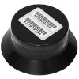
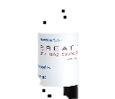

Where can I go for more information?

Health Canada Publications:

Radon - What you need to know,
http://www.hc-sc.gc.ca/ewh-semt/pubs/contaminants/radon/index-eng.php

Radon Reduction Guide for Canadians,
http://www.hc-sc.gc.ca/ewh-semt/pubs/radiation/radon_canadians-canadiens/index-eng.php

Health Canada Research Papers:

Summary Report on Active Soil Depressurization (ASD) Field Study
https://www.canada.ca/en/health-canada/services/environmental-workplace-health/radiation/radon/summary-report-active-soil-depressurization-field-study.html
Residential Radon Mitigation Actions Follow-Up Study
https://www.canada.ca/en/health-canada/services/publications/health-risks-safety/residential-radon-mitigation-actions-follow-up-study.html

Tarion Home Warranty: https://www.tarion.com/sites/default/files/2018-12/Radon_Infographic_2018.pdf
Lung Association - https://www.lung.ca/lung-health/air-quality/indoor-air-quality/radon
Canadian Cancer Society - http://www.cancer.ca/en/prevention-and-screening/reduce-cancer-risk/make-informed-decisions/know-your-environment/test-your-home-for-radon/?region=on
Canadian Association of Radon Scientists and Technologists (CARST) – www.carst.ca
Canadian National Radon Proficiency Program (C-NRPP) – www.c-nrpp.ca
Take Action on Radon – www.takeactiononradon.ca
Canadian Real Estate Association (CREA) - https://www.crea.ca/wp-content/uploads/2016/02/A_Homeowners_Guide_to_Radon_CREA.pdf

